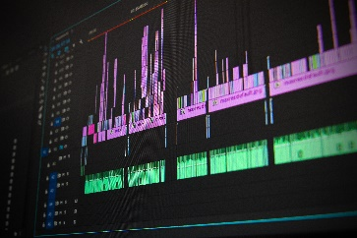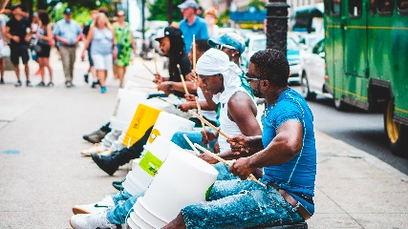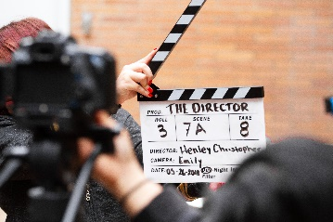
Applications of Music
MUS701/702 and MUS801/802 *link to course
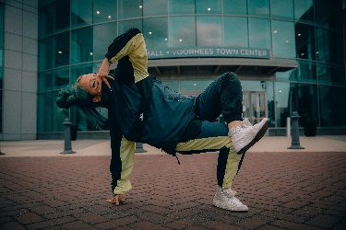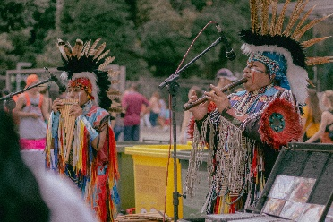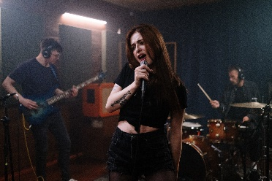
An Overview:
Applications of Music is a year-long course that explores multiple facets of performing arts including music in the media, music as a change agent, music as a cultural phenomenon, performance practices in music, and exploration of select instruments (guitar, drums, piano). This course rounds out the performing arts offerings (in addition to band, choir, orchestra) as the performance-based option for 7th and 8th grade students. Performance takes place in each unit in a formal or information presentation of their creation.
This course will be under revision during the 2021-2022 school year and will be added to for the 2022-2023 school year to become a two-year course to be taken by 7th and 8th grade students.
The course will be delivered through a variety of modalities including whole group, small group, and individual instruction. The content is housed and data is collected in Canvas.
Table of Contents
An Overview 1
Academic Topics and Grading Practices 2
Unit Topics of Study Overview 2
Recommended Pacing 3
Considerations for All Unit Topics 3
Units of Study 4-11

Academic Topics and Grading Practices:
Applications of Music has 4 academic topics: Create, Connect, Present, Respond. The following chart provides the target language for each topic:
Topic 1: Create | Topic 2: Connect | Topic: Present | Topic 4: Respond
3A: Accurately reads and performs notated music.  3B: Demonstrates proper technique. | 3A: Collaborates with others and contributes to classroom success using focal point and self-awareness.  3B: Demonstrates and reflects on active listening skills and set self-improvement goals. | 3A: Prepared to perform for an audience using communication skills.  3B: Reflects on performances and set self-improvement goals. | 3A: Evaluates elements in music.  3B: Describe connections between artforms.

Students must engage with all targets a minimum of twice during the school year. Note that most, but not all, unit topics cover all academic topics and targets.
Teachers will make determinations about how and in what ways to collect data. Summative tasks are built into each Unit Topic, but may be changed/adjusted/added to per the student's needs.

Unit Topics of Study:
10 Topics have been created by DMPS educators as listed below:
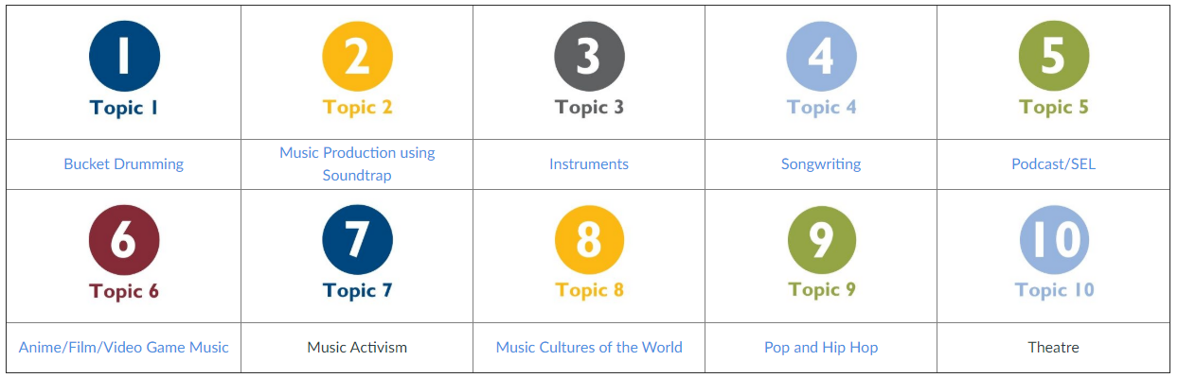
*Topics 7 and 10 will be available for students in semester two
Each topic follows a 3-section cycle: Explore, Create, Present
Within each section there are lessons for the students to move through.
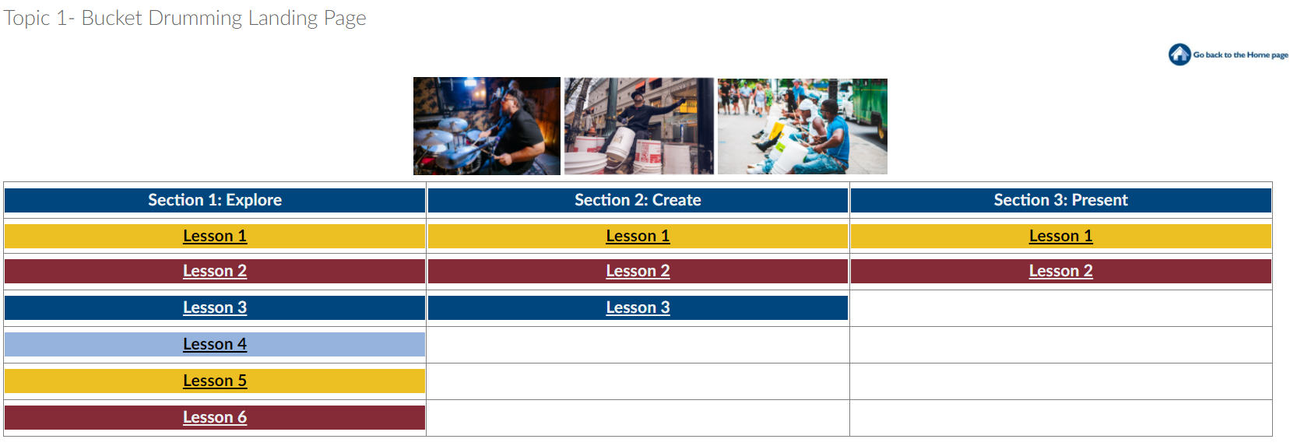
Note: Using the Topics, Sections, and Lessons will help students know what they need to accomplish. Using the shorthand for the topics will help you and students track their progress.
Example: T1 S2 L1 – Topic 1 (Bucket Drumming), Section 2 (Create), Lesson 1
Recommended Pacing:
Each topic was written to fit inside a 6 week window on an A/B schedule (3 total weeks of instruction). All students should begin with Topic 1 as it is best suited for whole class instruction. Topic 2 Music Production using Soundtrap is the recommended second topic as students learn skills needed for many other topics. Topic 2 is a pre-requisite for Topics 4, 5, 6, 7, and 8.
After the first two topics are covered, students will be able to choose which of the remaining topics they want to engage in. This should give you, the educator, some freedom to run 2 or 3 topics concurrently in your room under a modified flipped classroom model. Or, if all students want to engage in a particular topic, you could continue to run whole class instruction.
Teachers will need to maintain and edit the course to personalize the experience for their own building. They will also need to adjust and communicate timelines for students as they move through a topic.
At the beginning of the course, the teacher should share the following process with students:
We will begin with Topic 1 Bucket Drumming and follow it with Topic 2 Music Production using Soundtrap. After that you will be able to select 4 of the remaining topics to engage in throughout the rest of the school year (18 weeks in a semester, the first 12 are accounted for).
Considerations for All Unit Topics:
- Embedded Checkpoints – how will you use these AND/OR collect responses?
- Pacing – How many lessons do students need to accomplish in a day? Will you spend more or less time on certain things?
- Monitoring – how will you collect data/progression/mastery within the lesson? Observation? Student self tracking?

Units of Study:
Topic 1 Bucket Drumming
Pre-requisite Topic: None

Topic 1: Create | Topic 2: Connect | Topic: Present | Topic 4: Respond
3A: Accurately reads and performs notated music.  3B: Demonstrates proper technique. | 3A: Collaborates with others and contributes to classroom success using focal point and self-awareness.  3B: Demonstrates and reflects on active listening skills and set self-improvement goals. | 3A: Prepared to perform for an audience using communication skills.  3B: Reflects on performances and set self-improvement goals.

In this topic students will:
- Review and Practice takadimi skills
- Learn proper bucket drumming technique
- Practice
- Reflect
- Work on improvisation
- Compose
- Work in a group
- Present

Teacher Considerations:
- How will you collect data throughout the Topic?
- Update/Publish Discussions as you see fit
- FINAL PROJECT – details for submission
- Edit Resources Page

Topic 2 Music Production Using Soundtrap
Pre-requisite Topic: None

Topic 1: Create | Topic 2: Connect | Topic: Present | Topic 4: Respond
3A: Accurately reads and performs notated music.  3B: Demonstrates proper technique. | 3A: Collaborates with others and contributes to classroom success using focal point and self-awareness.  3B: Demonstrates and reflects on active listening skills and set self-improvement goals. | 3A: Prepared to perform for an audience using communication skills.  3B: Reflects on performances and set self-improvement goals. | 3A: Evaluates elements in music.  3B: Describe connections between artforms.

In this topic students will:
- Explore Soundtrap (each student has their own login)
- Learn how to create beats/loops/add instruments/record/etc.
- Explore the 8 Elements of Music (Dynamics, Form, Harmony, Melody, Rhythm, Texture, Timbre, Tonality)
- Create within Soundtrap
- Write a Statement of Artistic Intent
- Combine learned skills into a final project
Teacher Considerations:
- How will you collect data throughout the Topic?
- Update/Publish Discussions as you see fit
- FINAL PROJECT – details for submission
- Edit Resources Page

Topic 3 Instruments
Pre-requisite Topic: Topic 1 Bucket Drumming

Topic 1: Create | Topic 2: Connect | Topic: Present | Topic 4: Respond
3A: Accurately reads and performs notated music.  3B: Demonstrates proper technique. | 3A: Collaborates with others and contributes to classroom success using focal point and self-awareness.  3B: Demonstrates and reflects on active listening skills and set self-improvement goals. | 3A: Prepared to perform for an audience using communication skills. | 3A: Evaluates elements in music.  3B: Describe connections between artforms.

In this topic students will:
- Determine a pathway to follow: Piano – Ukulele – Guitar
All Lessons Contain:
- History of the instrument/How it works
- Playing Technique
- Reading Music/Notes
- Takadimi Review
- Practice
- Performance
Teacher Considerations:
- How will you collect data throughout the Topic?
- Update/Publish Discussions as you see fit
- FINAL PROJECT – details for submission
- Edit Resources Page
- BLOOKET Login

Topic 4 Songwriting
Pre-requisite Topic: Topic 1 Bucket Drumming and Topic 3 Instruments

Topic 1: Create | Topic 2: Connect | Topic: Present | Topic 4: Respond
3A: Accurately reads and performs notated music.  3B: Demonstrates proper technique. | 3A: Collaborates with others and contributes to classroom success using focal point and self-awareness.  3B: Demonstrates and reflects on active listening skills and set self-improvement goals. | 3A: Prepared to perform for an audience using communication skills.  3B: Reflects on performances and set self-improvement goals. | 3A: Evaluates elements in music.  3B: Describe connections between artforms.

In this topic students will:
- Think about the ‘Why’ of writing a Song
- Learn the steps of songwriting
- Explore in the Elements of Music
- Write a song (first with the class, then on their own)
Teacher Considerations:
- How will you collect data throughout the Topic?
- Update/Publish Discussions as you see fit
- FINAL PROJECT – details for submission
- Edit Resources Page
- NOTEFLIGHT Login

Topic 5 Podcast/SEL
Pre-requisite Topic: Topic 2 Music Production Using Soundtrap

Topic 1: Create | Topic 2: Connect | Topic: Present | Topic 4: Respond
3A: Accurately reads and performs notated music.  3B: Demonstrates proper technique. | 3A: Collaborates with others and contributes to classroom success using focal point and self-awareness.  3B: Demonstrates and reflects on active listening skills and set self-improvement goals. | 3A: Prepared to perform for an audience using communication skills.  3B: Reflects on performances and set self-improvement goals. | 3A: Evaluates elements in music.  3B: Describe connections between artforms.

In this topic students will:
- Explore SEL components and real-life connections
- Create an ‘SEL Playlist’
- Create an Artist Statement
- Explore different podcast genres
- Create a podcast in a small group
- Present
- Reflect
Teacher Considerations:
- How will you collect data throughout the Topic?
- Update/Publish Discussions as you see fit
- FINAL PROJECT – details for submission
- Edit Resources Page

Topic 6 Anime/Film/Video Game Music
Pre-requisite Topic: Topic 2 Music Production Using Soundtrap

Topic 1: Create | Topic 2: Connect | Topic: Present | Topic 4: Respond
 | 3A: Collaborates with others and contributes to classroom success using focal point and self-awareness.  3B: Demonstrates and reflects on active listening skills and set self-improvement goals. | 3A: Prepared to perform for an audience using communication skills. | 3A: Evaluates elements in music.  3B: Describe connections between artforms.

In this topic students will:
- All students must do the introduction to the unit prior to choosing a pathway**
- Determine a pathway to follow: Anime Music – Film Music – Video Game Music
All Lessons Contain:
- History of that type of music
- Reflection on the type of music
- Explore how music impacts a scene (using elements of music)
- Film Music Specific Notes
  - John Williams Sound Clips – review and edit as needed
  - Kahoot – can play as an individual or whole class
- Create storyboard scenes
- Big understanding: Leitmotif
Teacher Considerations:
- How will you collect data throughout the Topic?
- Update/Publish Discussions as you see fit
- FINAL PROJECT – details for submission
- Edit Resources Page
- Storyboard That Login

Topic 7 Music Activism (Available Semester 2)
Pre-requisite Topic: Topic 2 Music Production Using Soundtrap

Topic 1: Create | Topic 2: Connect | Topic: Present | Topic 4: Respond
3A: Accurately reads and performs notated music.  3B: Demonstrates proper technique. | 3A: Collaborates with others and contributes to classroom success using focal point and self-awareness.  3B: Demonstrates and reflects on active listening skills and set self-improvement goals. | 3A: Prepared to perform for an audience using communication skills.  3B: Reflects on performances and set self-improvement goals. | 3A: Evaluates elements in music.  3B: Describe connections between artforms.

Topic 8 Music Cultures of the World
Pre-requisite Topic: Topic 2 Music Production Using Soundtrap
Topic 1: Create | Topic 2: Connect | Topic: Present | Topic 4: Respond
 | 3A: Collaborates with others and contributes to classroom success using focal point and self-awareness.  3B: Demonstrates and reflects on active listening skills and set self-improvement goals. | 3A: Prepared to perform for an audience using communication skills.  3B: Reflects on performances and set self-improvement goals. | 3A: Evaluates elements in music.  3B: Describe connections between artforms.

In this topic students will:
- Define what makes up a culture
- Explore elements of music through various cultures
- Use the Four Step Critical Analysis format to respond to music elements
- Research
- Create
- Present
Teacher Considerations:
- How will you collect data throughout the Topic?
- Update/Publish Discussions as you see fit
- FINAL PROJECT – details for submission
- Edit Resources Page

Topic 9 Pop and Hip Hop
Pre-requisite Topic: Topic 2 Music Production Using Soundtrap

Topic 1: Create | Topic 2: Connect | Topic: Present | Topic 4: Respond
3A: Accurately reads and performs notated music.  3B: Demonstrates proper technique. | 3A: Collaborates with others and contributes to classroom success using focal point and self-awareness.  3B: Demonstrates and reflects on active listening skills and set self-improvement goals. | 3A: Prepared to perform for an audience using communication skills.  3B: Reflects on performances and set self-improvement goals. | 3A: Evaluates elements in music.  3B: Describe connections between artforms.

In this topic students will…
- All students must do the introduction to the unit prior to choosing a pathway**
- Determine a pathway to follow: Pop – Hip Hop
- NOTE: There are several exploration points where students choose who to listen to. It is important that students engage in school appropriate materials.
All Lessons Contain:
- History of that type of music
- Reflection on the type of music (what is it/why do we like it)
- Structure of the music
- Creating chords in SoundTrap
- Creating their own project

Teacher Considerations:
- How will you collect data throughout the Topic?
- Update/Publish Discussions as you see fit
  - **Pay special attention to daily icon discussions**
- FINAL PROJECT – details for submission
- Edit Resources Page
- Topic 9 Pop S1 L3 page 1 of 2: VH1 Documentary is 33 min long. Determine what students will engage in within the video
- Topic 9 BOTH Pop and Hip Hop S1 L3 and L4: This is a Soundtrap review/exploration. Determine if students need the review or unpublish the page
- Support students in making school-appropriate choices in their listening and exploring
Topic 10 Theatre (Available Semester 2)
Pre-requisite Topic: None

Topic 1: Create | Topic 2: Connect | Topic: Present | Topic 4: Respond
3A: Accurately reads and performs notated music.  3B: Demonstrates proper technique. | 3A: Collaborates with others and contributes to classroom success using focal point and self-awareness.  3B: Demonstrates and reflects on active listening skills and set self-improvement goals. | 3A: Prepared to perform for an audience using communication skills.  3B: Reflects on performances and set self-improvement goals. | 3A: Evaluates elements in music.  3B: Describe connections between artforms.

