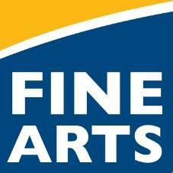
Des Moines Public School Instrument Rental Agreement

Student Name Parent or Guardian

Home Phone

Work Phone
Address

Email
The above student is eligible to use the school-owned instrument indicated below if:

The rental agreement is signed.
The student regularly attends instrumental music class.
The instrument, accessories, and case are maintained in good condition.
The student purchases or attains the required course music book, which can be purchased from your student's school.
School: Amount Due: $50.00*

Instrument: Make:
Included Accessories (i.e. mouthpiece)

Serial Number: Model:

Rental period ends on: May 27th, 2020
I hereby request use of the instrument and accessories described above.
I agree to all the terms of this agreement and realize that the $50 fee is non-refundable once the instrument has been received by the student.

* This fee is tied to the Household Economic Survey you completed during the Online Registration process. If your student qualifies for free or reduced textbook rental fees, then this fee will be reduced or fully waived by the Infinite Campus System. Once this agreement is completed in full and returned to the teacher, the Office Manager will assign the fee in your students' fee tab. You will be notified by the school Office Manager or Bookkeeper if you need to pay this fee. Ways to pay include: Cash, check or money order hand delivered to the Office Manager, online through the district web store found on the district website, or with a credit card in person or over the phone.

I agree to be responsible for any damage or loss that may occur while in my care, including string/reed/mouthpiece replacement needs and shall pay the cost of repair or replacement upon request. Normal “wear and tear” will be covered by the $50 rental fee.

If the instrument is damaged while in my care I agree to pay in full for the replacement. I understand that I will not be able to rent another instrument from DMPS until the assessed fee is paid in full.

Rental instruments must be returned at the end of the rental period or earlier if the student ceases to meet the eligibility requirements listed above.

Parent or Guardian Signature:

Student Signature:
Date:

Date:

Teacher Signature: Date:

