Center 1 Choir Room #1390, Center 2 Orchestra Room #1395
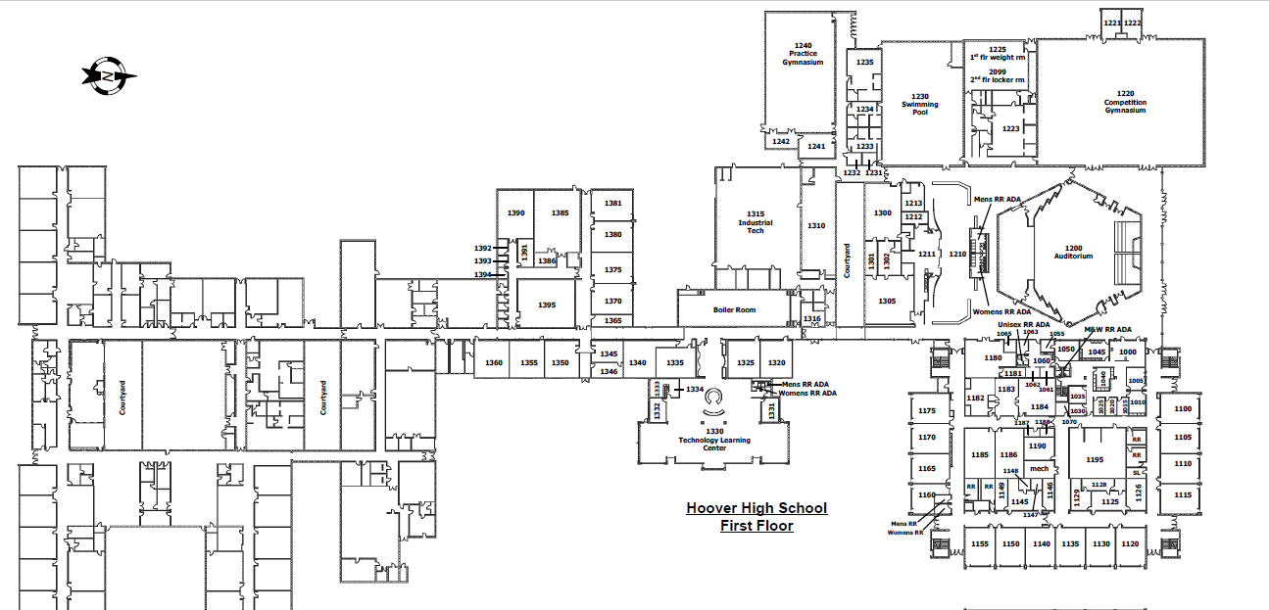
Enter through the marked door below off of Beaver Avenue. You may park in the attached parking lot
Madison
Ave
Aurora Ave
Parking Lot Here
Here
Enter Here
text here

Beaver Avenue

