1.
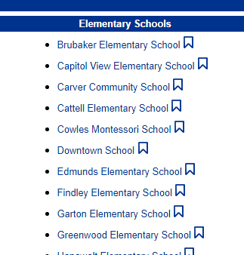
Click Circulation
Click on the school you wish to inventory.

2.
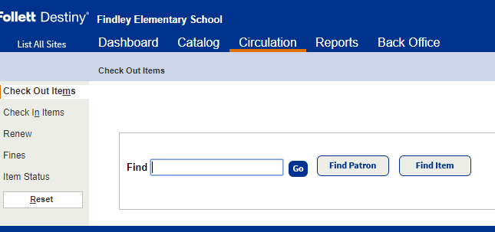
3.
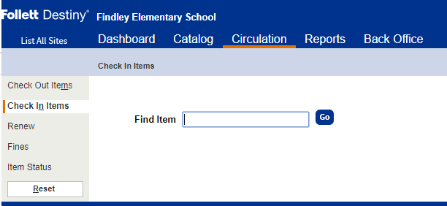
Click ‘Check In Items’ and begin scanning or entering barcode.
Hit the enter button or ‘Go’.
This will automatically bring the item to ‘checked in an available’ in Destiny. It will remove any other designations, such as ‘Lost’ or ‘In Use’.

Need help?
Contact: Kelly Kretschmer Phone: 515.242.7609 Email: Kelly.kretschmer@dmschools.org

