Choose Your Building
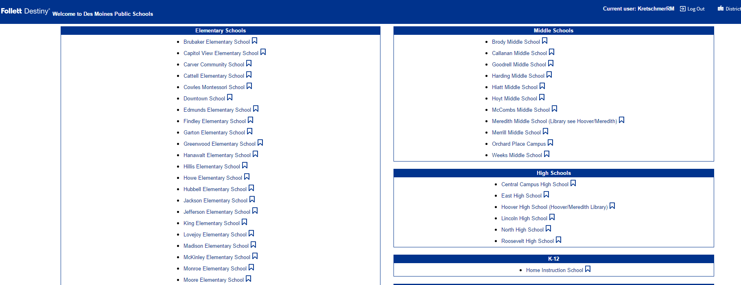

Click ‘Back Office’
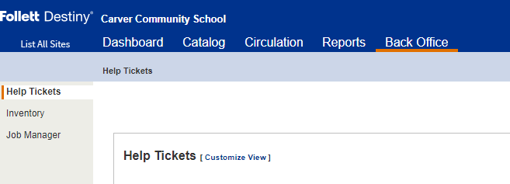

Click ‘Inventory’
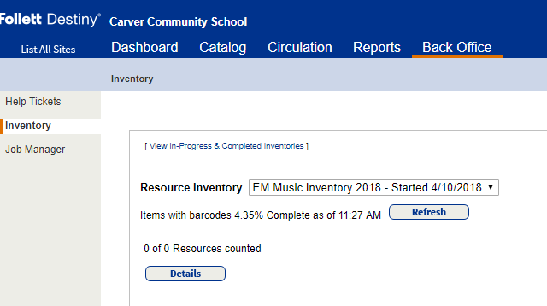
- Double check that the drop-down says your correct grade level ‘EM Music Inventory 2018’
  - Middle Schools – MS Music Inventory 2018
  - High Schools – HS Music Inventory 2018
THIS WILL SHOW YOU THE TOTAL % YOU HAVE CHECKED IN.

To see further details on your percentage, click ‘Details’

To see the items in the ‘Accounted for’ and ‘Unaccounted for’ number, click (See Details)
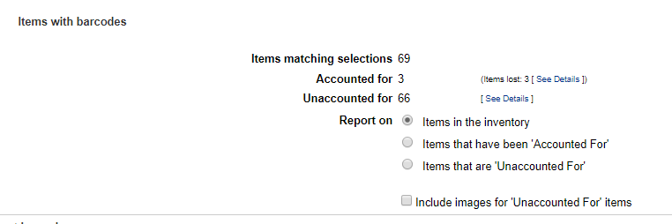

You will find the exact list of items that still need to be scanned/have been scanned/are lost (according to which ‘See Details’ you selected):
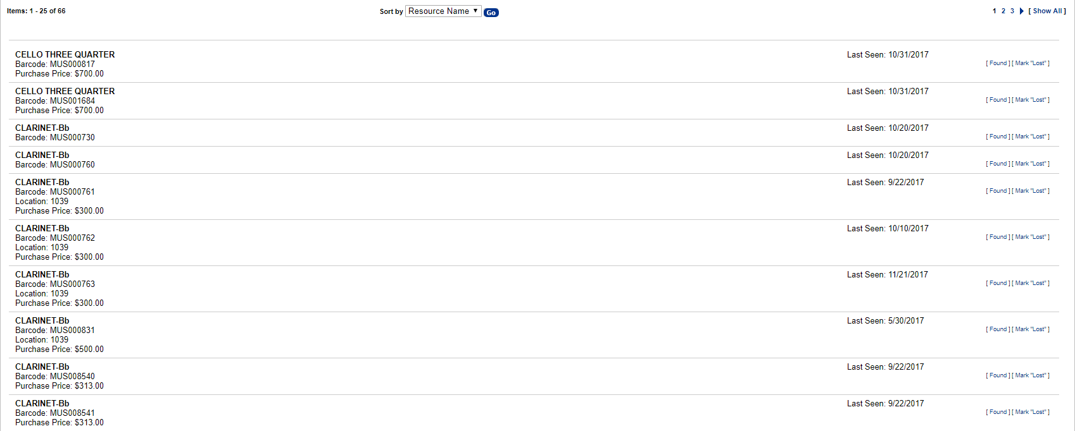

You may also ‘Run Report’ which will detail every aspect of your inventory regarding check-out/check-in. Click ‘Run Report’:
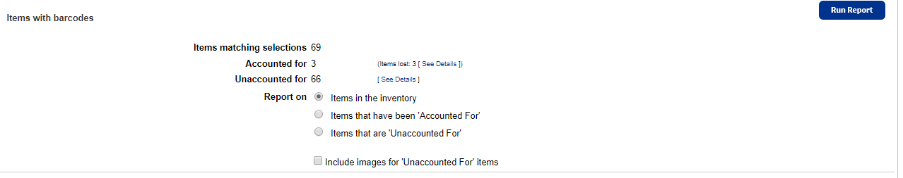

You will be directed to this screen:
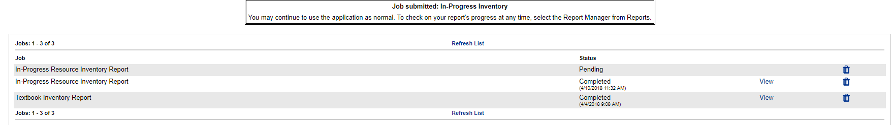

Click ‘Refresh List’ on the bottom:

Once it has processed, it will say ‘Completed’. Click ‘View’:
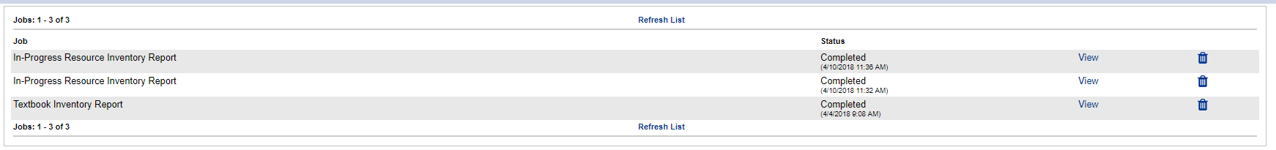

Choose which view you’d like to see it in (I prefer Barcode Report best):
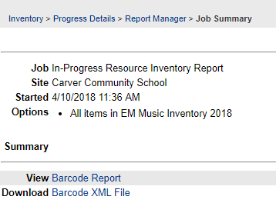

It will pull a report for you that looks like this:
